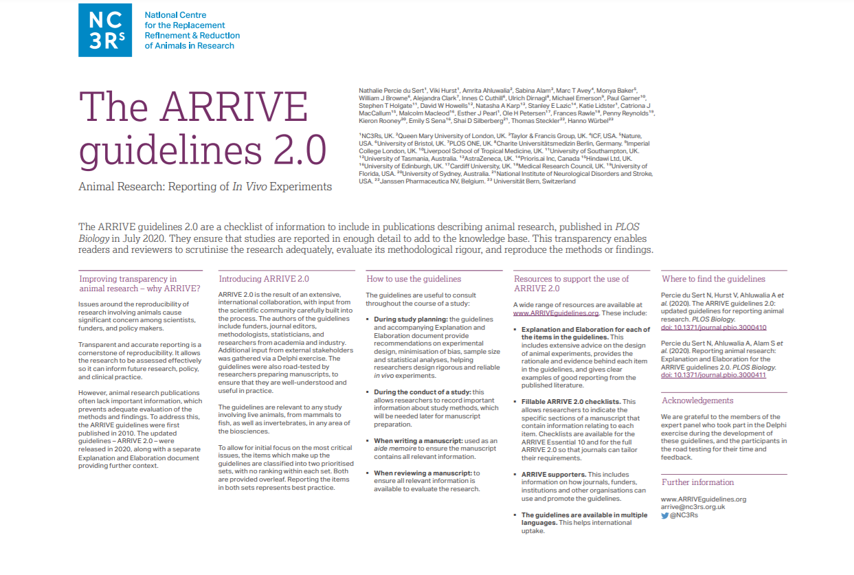
The ARRIVE Essential 10
These items are the basic minimum to include in a manuscript. Without this information, readers and reviewers cannot assess the reliability of the findings. |  |  | Line number, or  Reason for not  reporting
Study design | 1 | For each experiment, provide brief details of study design including:  a.The groups being compared, including control groups. If no control group has been used, the rationale should be stated.  b.The experimental unit (e.g. a single animal, litter, or cage of animals).
Sample size | 2 | a.Specify the exact number of experimental units allocated to each group, and the total number in each experiment. Also indicate the total number of animals used.  b.Explain how the sample size was decided. Provide details of any a priori sample size calculation, if done.
Inclusion and exclusion criteria | 3 | - Describe any criteria used for including and excluding animals (or experimental units) during the experiment, and data points during the analysis. Specify if these criteria were established a priori. If no criteria were set, state this explicitly.  - For each experimental group, report any animals, experimental units or data points not included in the analysis and explain why. If there were no exclusions, state so.  c.For each analysis, report the exact value of n in each experimental group.
Randomization | 4 | a . State whether randomisation was used to allocate experimental units to control and treatment groups. If done, provide the method used to generate the randomisation sequence.  b . Describe the strategy used to minimise potential confounders such as the order of treatments and measurements, or animal/cage location. If confounders were not controlled, state this explicitly.
Blinding | 5 | Describe who was aware of the group allocation at the different stages of the experiment (during the allocation, the conduct of the experiment, the outcome assessment, and the data analysis).
Outcome measures | 6 | a .Clearly define all outcome measures assessed (e.g. cell death, molecular markers, or behavioural changes).  b . For hypothesis-testing studies, specify the primary outcome measure, i.e. the outcome measure that was used to determine the sample size.
Statistical methods | 7 | - Provide details of the statistical methods used for each analysis, including software used.  - Describe any methods used to assess whether the data met the assumptions of the statistical approach, and what was done if the assumptions were not met.
Experimental animals | 8 | - Provide species-appropriate details of the animals used, including species, strain and substrain, sex, age or developmental stage, and, if relevant, weight.  - Provide further relevant information on the provenance of animals, health/immune status,genetic modification status, genotype, and any previous procedures.
Experimental procedures | 9 | For each experimental group, including controls, describe the procedures in enough detail to allow others to replicate them, including:  a.What was done, how it was done and what was used.  b.When and how often.  - Where (including detail of any acclimatisation periods).  - Why (provide rationale for procedures).
Results | 10 | For each experiment conducted, including independent replications, report:  - Summary/descriptive statistics for each experimental group, with a measure of variability where applicable (e.g. mean and SD, or median and range).  - If applicable, the effect size with a confidence interval.

The Recommended Set
These items complement the Essential 10 and add important context to the study. Reporting the items in both sets represents best practice. |  |  | Line number, or reason for not reporting
Abstract | 11 | Provide an accurate summary of the research objectives, animal species, strain and sex,key methods, principal findings, and study conclusions.
Background | 12 | - Include sufficient scientific background to understand the rationale and context for the study, and explain the experimental approach.  - Explain how the animal species and model used address the scientific objectives and,where appropriate, the relevance to human biology.
Objectives | 13 | Clearly describe the research question, research objectives and, where appropriate,specific hypotheses being tested.
Ethical statement | 14 | Provide the name of the ethical review committee or equivalent that has approved the use of animals in this study, and any relevant licence or protocol numbers (if applicable). If ethical approval was not sought or granted, provide a justification.
Housing and husbandry | 15 | Provide details of housing and husbandry conditions, including any environmental enrichment.
Animal care and monitoring | 16 | a.Describe any interventions or steps taken in the experimental protocols to reduce pain,suffering and distress.  b.Report any expected or unexpected adverse events.  - Describe the humane endpoints established for the study, the signs that were monitored and the frequency of monitoring. If the study did not have humane endpoints, state this.
Interpretation/ scientific implications | 17 | - Interpret the results, taking into account the study objectives and hypotheses, current theory and other relevant studies in the literature.  - Comment on the study limitations including potential sources of bias, limitations of the animal model, and imprecision associated with the results.
Generalisability / translation | 18 | Comment on whether, and how, the findings of this study are likely to generalise to other species or experimental conditions, including any relevance to human biology (where appropriate).
Protocol registration | 19 | Provide a statement indicating whether a protocol (including the research question, key design features, and analysis plan) was prepared before the study, and if and where this protocol was registered.
Data access | 20 | Provide a statement describing if and where study data are available.
Declaration of interests | 21 | - Declare any potential conflicts of interest, including financial and non-financial. If none exist, this should be stated.  - List all funding sources (including grant identifier) and the role of the funder(s) in the design, analysis and reporting of the study.

*请注意在报告对动物处死的方法时是否符合国际“动物安乐死指南”的要求，水合氯醛不作为安乐死可接受的药物。
*此外，根据ICMJE要求， 请务必在文章末尾根据实际情况添加以下声明。请参考(红色部分要根据实际情况替换）：
Acknowledgment（未列入作者席的，在此致谢)
The authors thank all of the members of the data and safety monitoring board: Lixing Lao, PhD, MB; Claudia M. Witt, MD, MBA; Justin C.Y. Wu, MD; Hugh Macpherson, PhD; Zhaoxiang Bian, MD, PhD; Chen Yao, PhD; and Zhiwei Xia, MD (Supplement Table 1). They also thank Dr. Zhiwei Xia from Peking University Third Hospital for consultation and training in differential diagnosis of constipation; Prof. Xiaohua Zhou from the Department of Biostatistics, University of Washington, for design and statistical guidance; and Prof. Jiqian Fang from the School of Public Health, Sun Yat-sen University, for his guidance in the revision of our manuscript.
Author contributions
通信作者名字 had full access to all of the data in the study and takes responsibility for the integrity of the data and the accuracy of the data analysis.
Study concept and design: Hinman, McCrory, Pirotta, Relf, Forbes, Crossley, Harris, Reddy,
Acquisition, analysis, or interpretation of data: Hinman, McCrory, Pirotta, Relf, Forbes.
Drafting of the manuscript: Hinman, McCrory, Pirotta, Relf, Forbes, Kyriakides, Novy.
Critical revision of the manuscript for important intellectual content: Hinman, McCrory,
Statistical analysis: Forbes, Williamson, Metcalf, Reddy.
Obtained funding: Hinman, McCrory, Pirotta, Relf, Crossley, Reddy, Conaghan, Bennell.
Administrative, technical, or material support: McCrory, Relf, Kyriakides, Novy, Metcalf.
Study supervision: Hinman, McCrory, Pirotta, Relf, Bennell.
Role of the funding source
The study sponsor had no role in the design and conduct of the study; collection, management, analysis, and interpretation of the data; preparation, review, or approval of the manuscript; and decision to submit the manuscript for publication.
Declaration of competing interest
The authors declare that there is no known competing financial interests or personal relationships that could have appeared to influence the work reported in this paper.
State of animal rights
The intervention conformed to the ethical criteria.
Data sharing statement
You can contact the corresponding author for the data.

